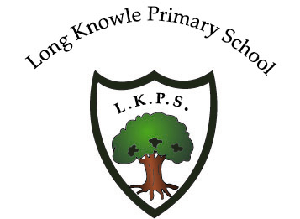
Long Knowle Primary School
Blackwood Avenue, Wednesfield, Wolverhampton WV11 1EB
E-mail: office@longknowleprimary.co.uk
Tel: 01902 558985
Fax: 01902 558986
Head Teacher: Ms K. Elliot

8th November 2021
PSHE/RSE Consultation
Dear Parents/Carers,
At Long Knowle we have recently reviewed our PSHE (Personal, Social, Health and Economic) Education curriculum and policy to ensure that they comply with guidance and is appropriate for the children at our school.
PHSE is at the core of our teaching and learning and enables our children to become independent, confident, resilient and healthy young people. Our PSHE curriculum is about the social, emotional and cultural development of our children. We will be following a programme called ‘Jigsaw’.
Following guidance from the DFE, we are required to incorporate RSE (Relationships and Sex Education) into our curriculum from September 2020. All schools are required to comply.
The aim of our ‘Relationships Education’ is to equip children with the information they need to prepare for adult life. The children will leave Long Knowle knowing the key building blocks of healthy, respectful relationships, focusing on family and friendships, in all contexts, including online. They will develop the skills to not only form relationships but to think about relationships with others and recognise when these relationships are positive.
At Long Knowle Primary School, we will be offering a Relationships Education in line with statutory guidance. As a school, and in agreement with the Governing Body, we have already agreed to teach the elements of Sex Education outlined in the Primary Science curriculum, separate from PSHE.
To ensure that our PSHE curriculum meets both statutory guidance as well as the needs of our school, we are consulting with parents. Consultation would ideally have been face to face, however, due to COVID-19 this is not possible.
Stage 1 - Online consultation with parents whilst we are unable to provide face to face meetings/workshops.
To help you to understand the requirements we need to meet, please look at:
- Our draft PSHE/RSE policy
- The appendices at the end of the policy which give an overview of the Jigsaw Curriculum across the school, an overview of some of the language we will be using and an overview of how Jigsaw meets the government’s guidance on Relationships Education in Schools (2019)
- The video we have made which explains how we teach PSHE/RSE at Long Knowle
Opportunity for feedback
When you have had chance to look at the policy and the video, please complete the PSHE/RSE CONSULTATION FORM which can be found on our website.
Stage 2
Following the consultation with parents, we will update our PSHE curriculum, taking into consideration feedback from parents along with feedback from staff/governors that we have already received. Once governors have agreed with all aspects with our curriculum, we will share finalised policies with you on our website and will implement our curriculum based on the scheme, ‘Jigsaw’. Jigsaw’s content is in line with DFE guidance .
The consultation period will end on Monday 22nd November at 9am.
Thank you for your support,
Ms K. Elliot
Head Teacher

